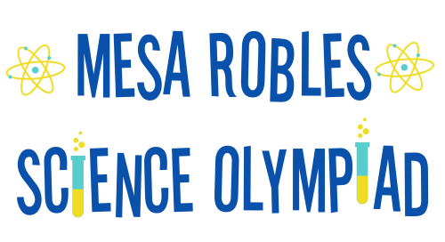
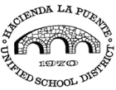
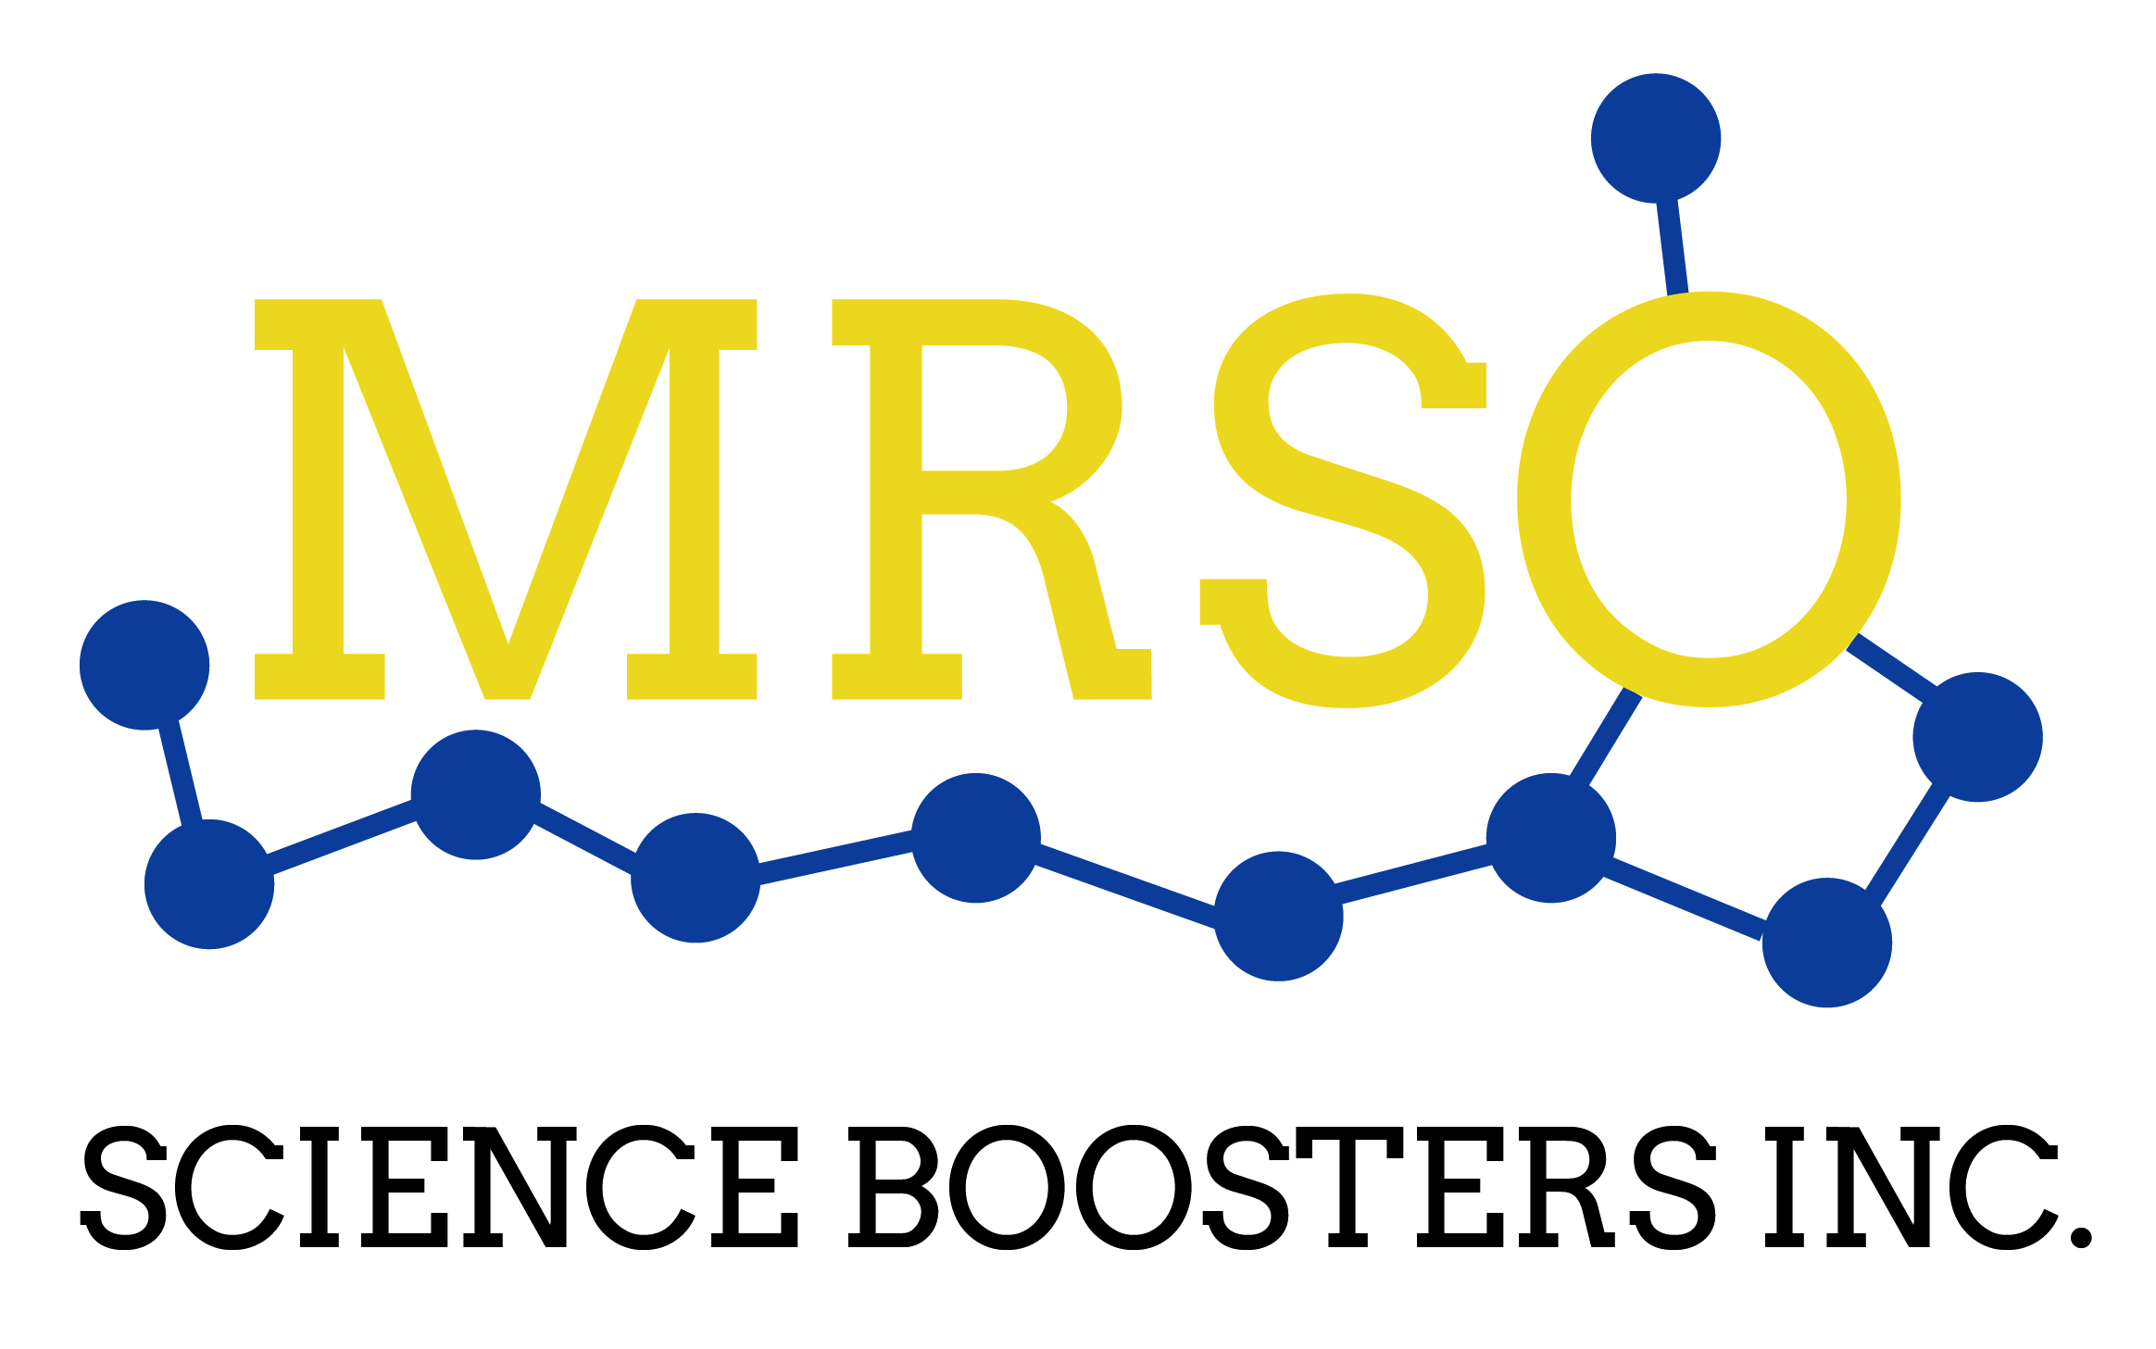

Mesa Robles Middle School 2016 Science Olympiad Invitational Tournament
Photographic Consent and Release Form

I hereby authorize the Hacienda La Puente Unified School District, Mesa Robles School, MRSO Science Boosters Inc. and Mesa Robles Science Olympiad to:
- Record my image, likeness, and/or voice on a photographic, video, audio, digital, electronic, or any other medium;
- Use, reproduce, modify, exhibit, and/or distribute any such recording for the awards ceremony slide show presentation and for future tournament advertising and promotional efforts; and
- Use my name in connection with any such recordings or uses.

Student Name (print): _____________________________________ Grade: ____________

Student Signature: _______________________________ Date: ______________________

Parent/Guardian Signature: ________________________________ Date: _____________

